Chapter 10, Solution 80.

Obtain v_{o}(t) for the op amp circuit in Fig. 10.123 if v_{s} = 4 cos (1000t - 60°) V.

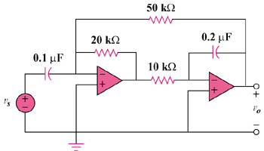

Figure 10.123
For Prob. 10.80.

Solution

The two stages are inverters so that
Therefore, 3.922 cos(1000t – 71.31) V

